**TGA Assignment – Pauthianlal Simte**

**Kubernetes artifacts [YAMLs] files**

|  |
| --- |
| File[livenessprobe.yaml](https://tools.publicis.sapient.com/bitbucket/projects/TXB/repos/t.-pauthianlal-simte/browse/k8s/livenessprobe.yaml) |
| File[mongo-deployment.yaml](https://tools.publicis.sapient.com/bitbucket/projects/TXB/repos/t.-pauthianlal-simte/browse/k8s/mongo-deployment.yaml) |
| File[mongo-service.yaml](https://tools.publicis.sapient.com/bitbucket/projects/TXB/repos/t.-pauthianlal-simte/browse/k8s/mongo-service.yaml) |
| File[user-deployment.yaml](https://tools.publicis.sapient.com/bitbucket/projects/TXB/repos/t.-pauthianlal-simte/browse/k8s/user-deployment.yaml) – **includes namespace, readiness and liveness probe** |
| File[user-ngress.yaml](https://tools.publicis.sapient.com/bitbucket/projects/TXB/repos/t.-pauthianlal-simte/browse/k8s/user-ngress.yaml) |
| File[user-service.yaml](https://tools.publicis.sapient.com/bitbucket/projects/TXB/repos/t.-pauthianlal-simte/browse/k8s/user-service.yaml) |
| loadbalancer-controller-policy.json |
|  |

**kubectl get pods, svc, deploy, ingress**

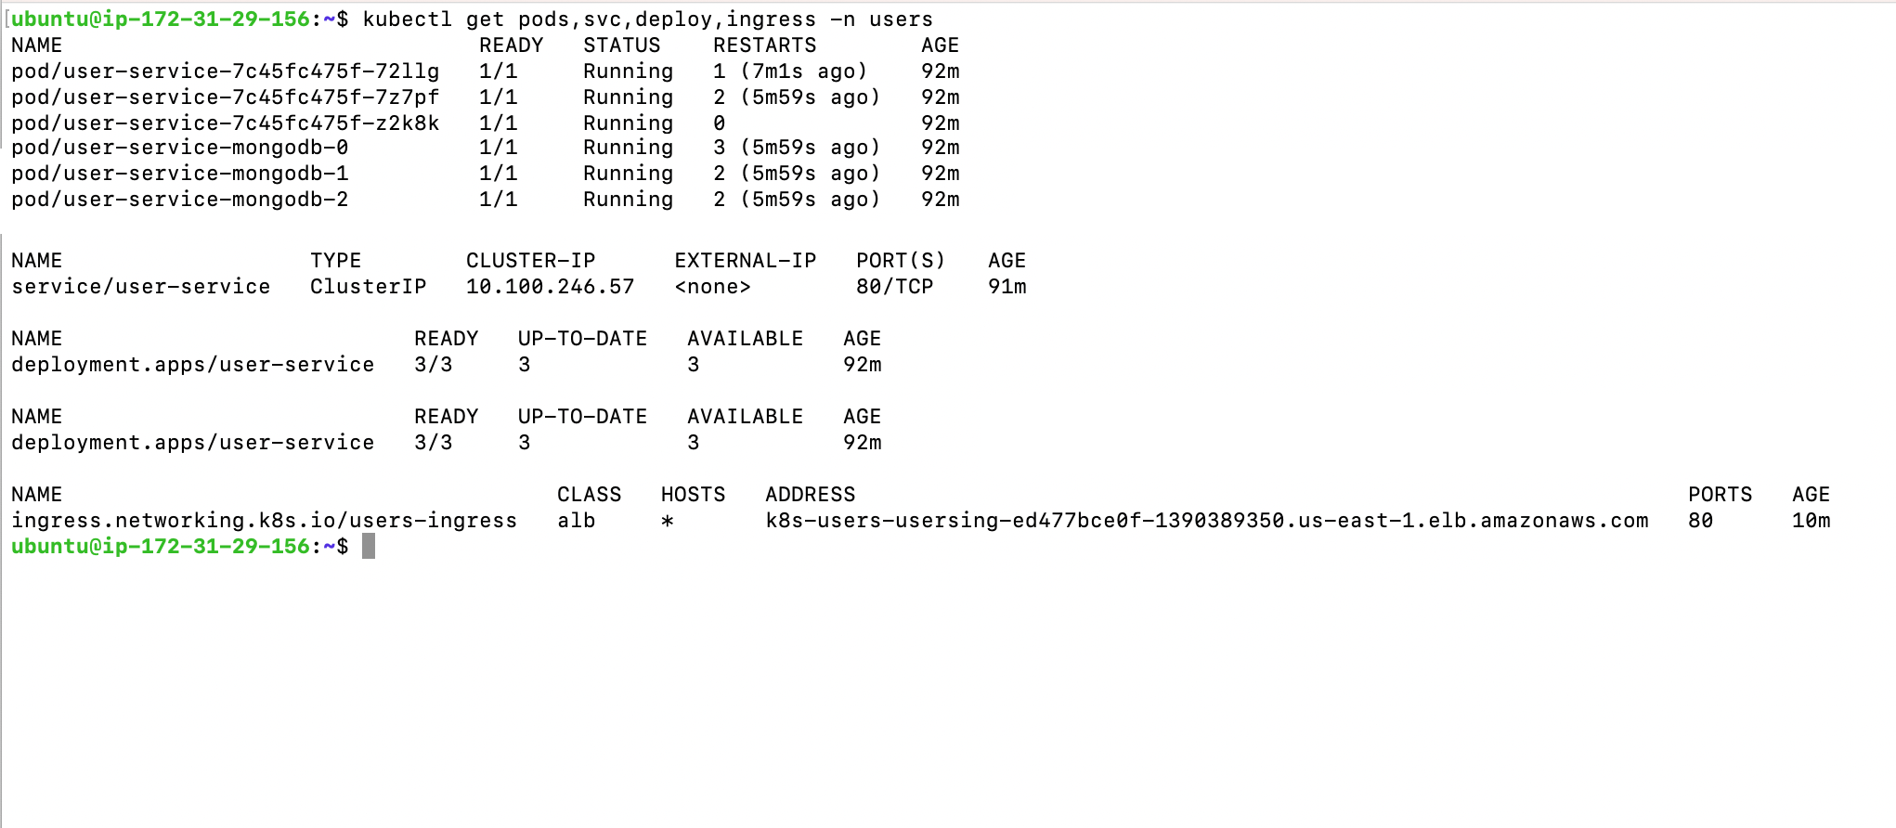

**2. INGRESS LOADBALANCER -> /users**

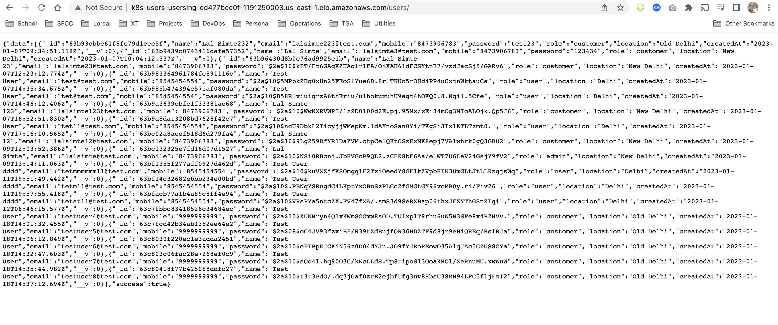

**3. INGRESS -> /users/:id**

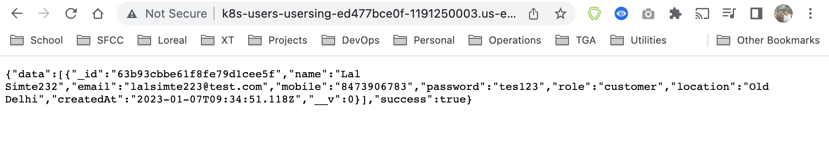

**4. Liveness Probe**

**ES2 Instance snapshot**

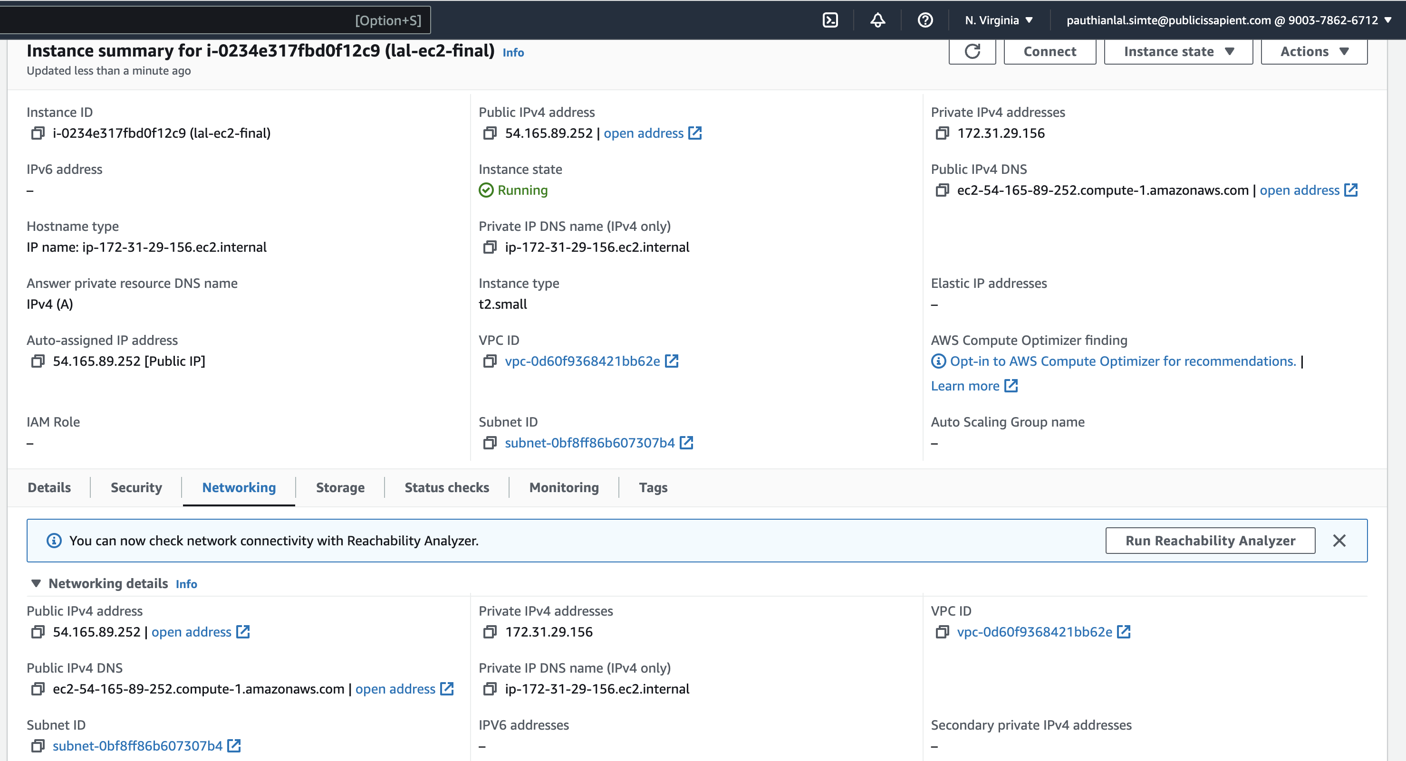

**EKS – Cluster**

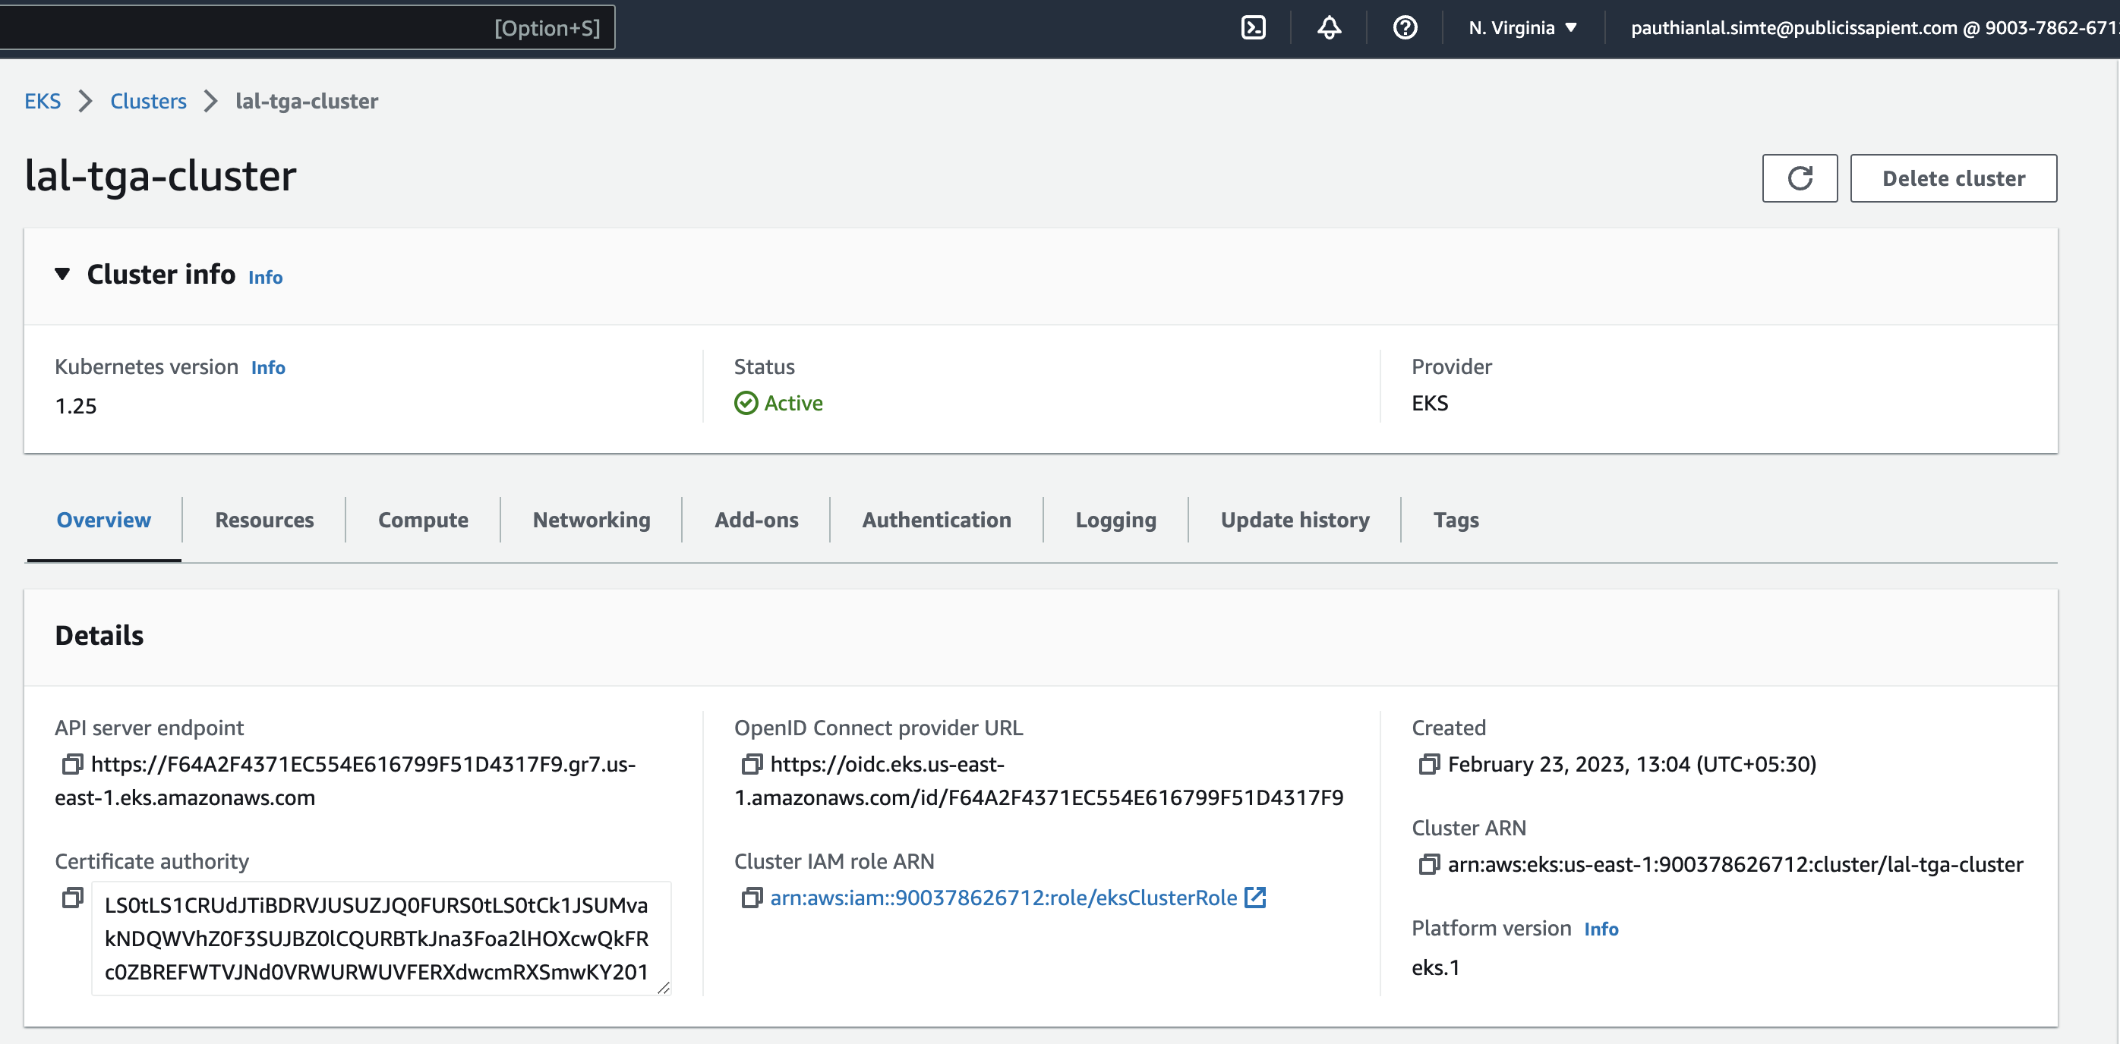

**- Pots snapshot:**

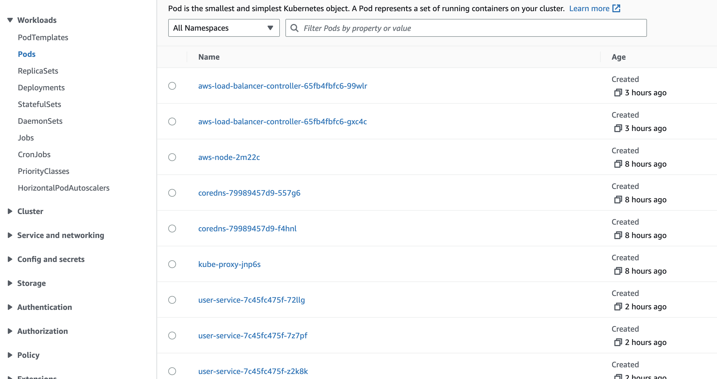

- Ingress Load Balancer

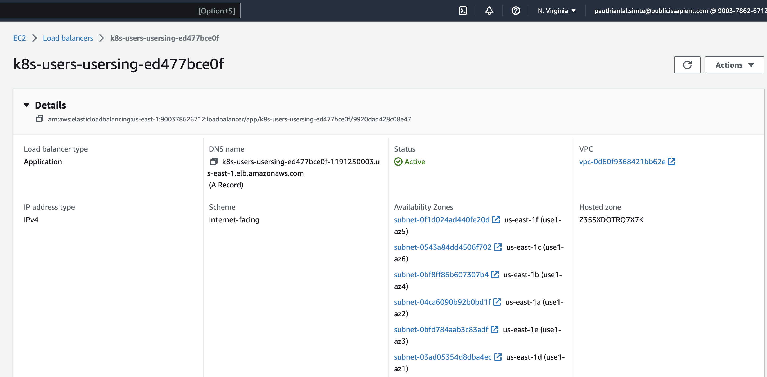

**User Service Open API (Swagger)**

